

**A PROJECT REPORT**

**TRAVEL BOOKING SYSTEM**

**SUBMITTED TO**

**SAVEETHA INSTITUTE OF MEDICAL AND TECHNICALSCIENCES**

**In partial fulfilment of the award of the course of**

**CSA1087: - Software Engineering for Web Development**

**SUBMITTED BY**

**AMRITA ARUN**

**Supervisor**

**Dr. B T Geetha.**



**SAVEETHA SCHOOL OF ENGINEERING, SIMATS**

**CHENNAI-602105**

**December-2024**

**Travel Booking System**

**Abstract**

The "Travel Booking System" project focuses on creating an intuitive and efficient platform for booking travel accommodations. The primary goal of this project is to address and resolve the inefficiencies present in traditional travel booking methods, such as the dispersal of information, lack of personalized options, and limited access to various services. Utilizing modern web technologies and user-centered design principles, the project successfully developed a functional prototype that simplifies the travel booking process.

Key objectives of the project included consolidating information about flights, hotels, and travel packages into a single accessible platform. This centralization aimed to streamline information, making it easier for users to find and book travel accommodations. Additionally, the system sought to provide users with personalized options and recommendations based on their preferences and travel history, thus enhancing customization. Ensuring the platform's user-friendliness and accessibility was also a priority, with an emphasis on catering to a diverse range of users, including those with limited technical skills.

The project employed an iterative development methodology, incorporating continuous user feedback to refine and improve the prototype. This user-centered approach allowed for the identification of areas needing enhancement and the inclusion of additional features based on user needs and market trends. By leveraging advanced web technologies, the system ensured a smooth and responsive user experience, meeting the project's technological objectives.

Key findings from the project highlighted the importance of consistent user feedback in enhancing the system's overall functionality. The iterative development approach proved beneficial in continuously refining the prototype, aligning it more closely with user expectations and market demands. The project concluded that integrating advanced features, such as real-time availability of services and secure payment gateways, could significantly enhance user satisfaction, further improving the travel booking experience.

In conclusion, the successful development of the "Travel Booking System" demonstrates the potential of modern technology in revolutionizing travel booking processes. The project underscores the importance of user feedback and iterative development in creating a platform that is efficient, personalized, and accessible. Future work will focus on further enhancing the system's capabilities and expanding its feature set to meet evolving user demands, ensuring continued user satisfaction and system effectiveness.

**Introduction**

Travel planning is a complex and often inconvenient process that involves searching, comparing, and booking various accommodations and transport options across multiple platforms. This traditional method of booking travel can lead to numerous inefficiencies, including increased costs, fragmented information, and suboptimal user experiences. As the digital revolution continues to transform various industries, it has become increasingly imperative to develop an integrated travel booking system that addresses these challenges, providing users with a more streamlined and efficient approach to planning their trips.

The primary objective of the "Travel Booking System" project is to create a user-centric platform that simplifies the process of booking travel accommodations. The system is designed to offer a seamless travel booking experience by consolidating various travel options into a single, centralized repository. This approach not only saves users time but also ensures that they have access to comprehensive and up-to-date information, enabling them to make informed decisions about their travel plans. By leveraging modern web development technologies such as HTML, CSS, and JavaScript, the project aims to create a responsive and intuitive interface that caters to the needs of a diverse range of travelers.

**Objectives**

The objectives of the "Travel Booking System" project are threefold:

1. **Design a platform for seamless travel booking:** The primary goal is to develop a user-friendly platform that allows travelers to book flights, hotels, and travel packages with ease. The system should provide a seamless and intuitive experience, reducing the complexity associated with traditional travel booking methods.
2. **Provide a centralized repository for travel options with search and filter capabilities:** The project aims to consolidate various travel options into a single platform, offering users a comprehensive repository of flights, hotels, and travel packages. Advanced search and filter capabilities will enable users to quickly find and compare different options based on their preferences and requirements.
3. **Enable users to book and manage travel plans efficiently:** The system will provide users with the tools to book and manage their travel plans efficiently. This includes features such as real-time availability, secure payment gateways, and personalized recommendations based on user preferences and travel history. By offering these capabilities, the project aims to enhance user satisfaction and streamline the travel booking process.

**Context**

The "Travel Booking System" project focuses on delivering a user-centric solution that leverages modern web development technologies. By utilizing HTML, CSS, and JavaScript, the project aims to create a responsive and visually appealing interface that provides an optimal user experience across various devices. Usability testing is a critical component of the project, ensuring that the system meets the needs and expectations of its intended audience. The primary target audience includes travelers seeking an intuitive and efficient platform for booking their travel accommodations. By addressing the inefficiencies and challenges associated with traditional travel booking methods, the project aims to revolutionize the way travelers plan and book their trips.

**Case Description**

**Scenario:** The Travel Booking System was envisioned as a web-based platform offering a range of travel options such as flights, hotels, and vacation packages. The platform integrates mock data to simulate real-world operations, providing a realistic yet controlled environment for testing.

**Setting:** The project was developed in an educational setting as part of a capstone requirement. The development team consisted of software developers and testers, guided by feedback from potential users.

**Challenges:**

1. Creating an inbuilt user interface that accommodates diverse user preferences.
2. Developing a scalable architecture capable of integrating additional features such as real-time updates and third-party APIs.
3. Testing the platform to ensure smooth functionality and usability.

**Outcomes:** The project delivered a functional prototype featuring a centralized search page, a detailed booking process, and basic data storage capabilities.

CODE:

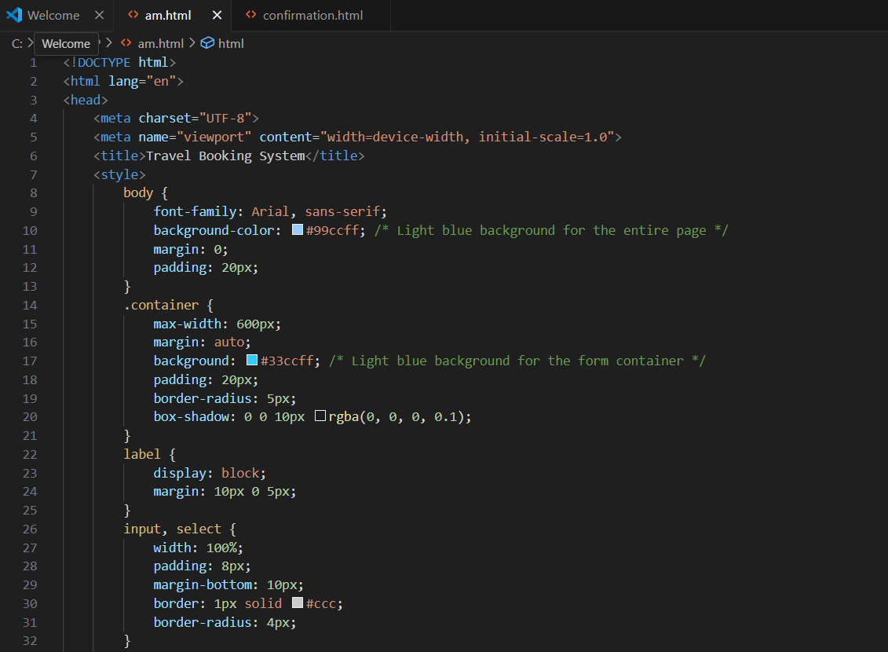

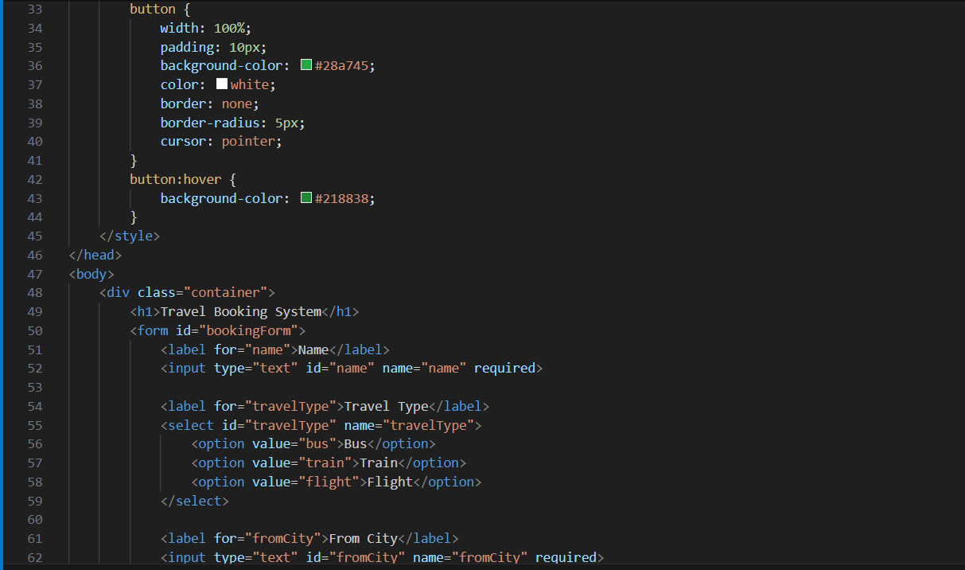

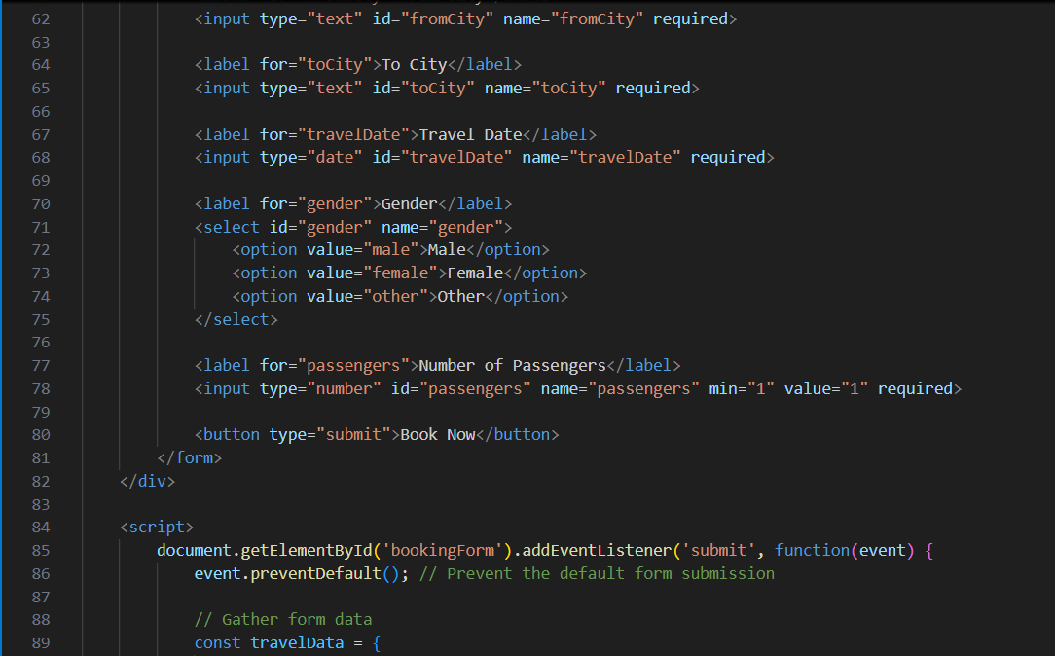

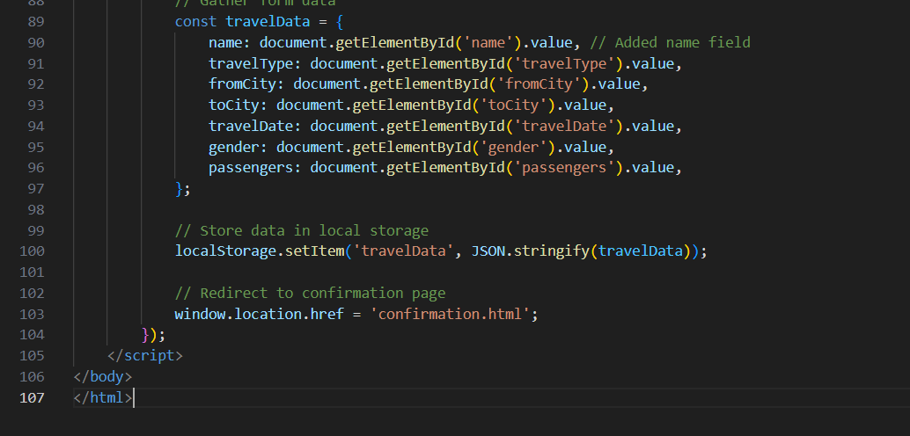

**EXECUTION:**

**Enter details and book now:**

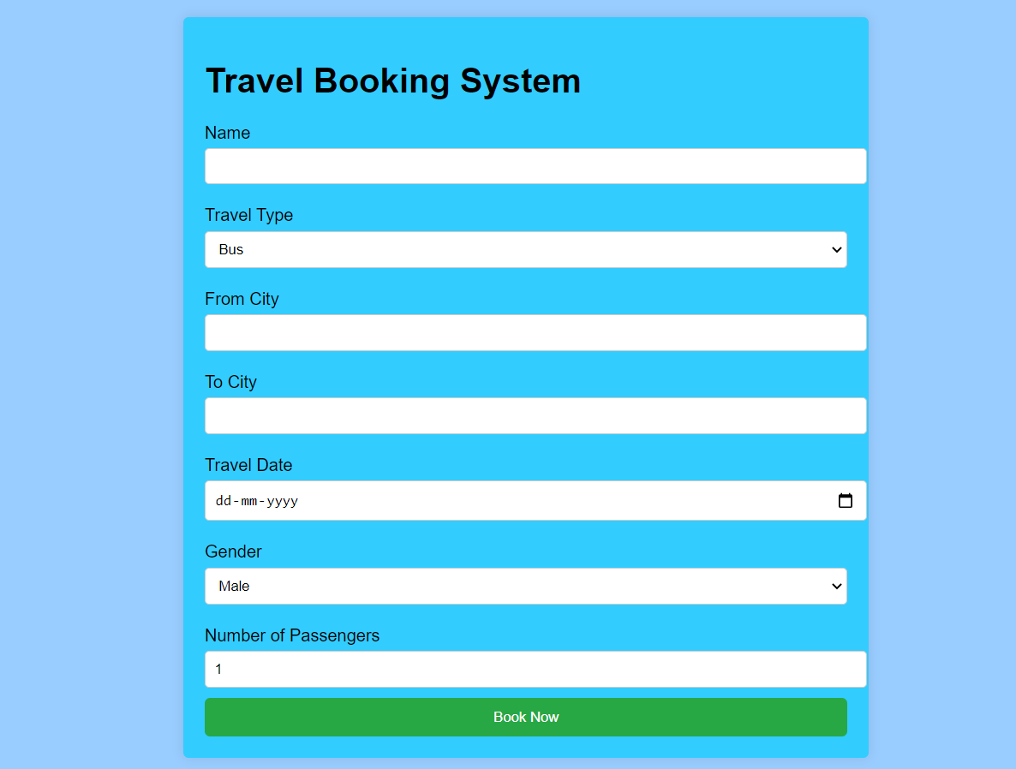

**OUTPUT:**

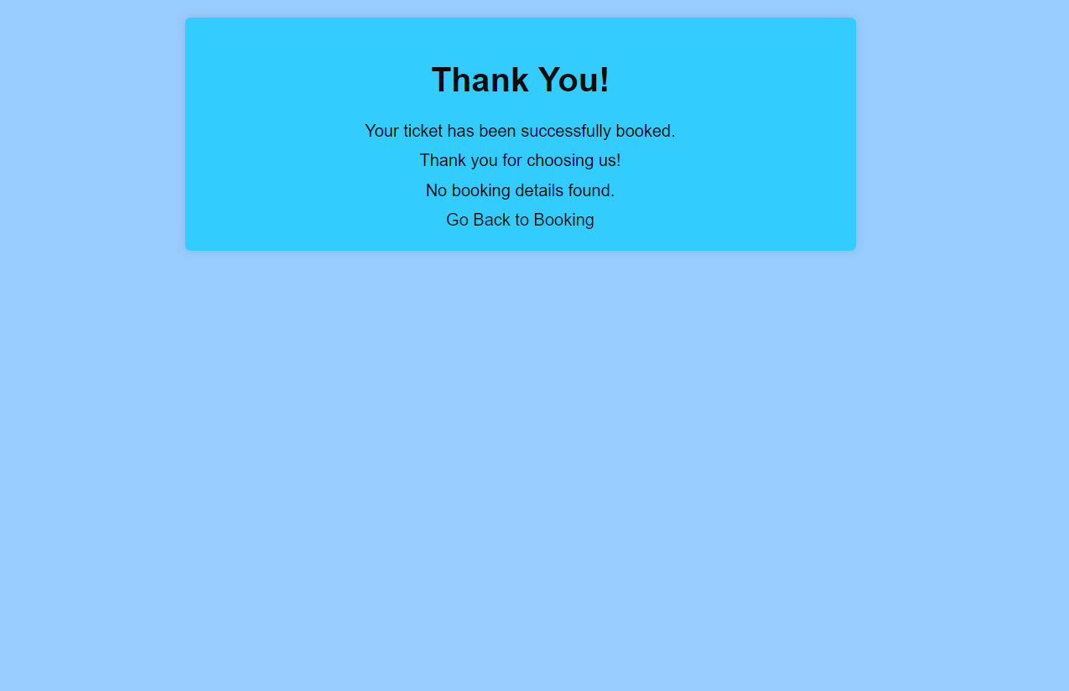

**Methods**

**Approach**

The methodology adopted for the "Travel Booking System" project encompasses several phases to ensure a comprehensive and user-focused development process.

**Research**: The initial phase involved conducting a thorough survey of existing travel platforms to identify prevalent features and common user pain points. This research was instrumental in understanding the market landscape and gathering insights into user expectations and industry standards. The aim was to discern both the strengths and weaknesses of current solutions in order to inform the development of a superior travel booking system.

**Design**: Following the research phase, the project moved into the design phase, which included creating detailed wireframes and user flow diagrams. These visual tools were essential for mapping out the application's structure and functionality. The wireframes provided a blueprint of the interface, while the user flow diagrams illustrated the journey a user would take through the system. This stage was crucial for visualizing the end product and ensuring that the design met user needs and project objectives.

**Development**: The development phase involved the implementation of the travel booking system using HTML, CSS, and JavaScript for the front end. This technological stack was chosen for its robustness and flexibility in creating a responsive and user-friendly interface. Additionally, a basic backend simulation was developed to handle data processing. Although this backend was simplified and did not employ a production-grade database, it served as an effective tool for simulating real-world data interactions and functionalities during the development process.

**Testing**: User testing sessions were conducted to identify usability issues and gather feedback. These sessions involved participants interacting with the prototype to perform predefined tasks. The insights gained from these sessions were invaluable for refining the system. Feedback was meticulously documented and categorized into usability issues and feature requests, ensuring that each piece of feedback could be systematically addressed in subsequent development cycles.

**Analysis**

The data collected from testing was analyzed and feedback was categorized into usability issues and feature requests. This categorization facilitated a focused approach to making improvements. The development process was iterative, meaning that the system was continually refined in response to user feedback. Each cycle of development incorporated changes and enhancements aimed at addressing identified issues and adding requested features.

**Limitations**

Despite its strengths, the project had certain limitations. The scope was limited by the absence of real-time integrations with third-party APIs. This restriction meant that some advanced features, such as real-time flight availability and booking confirmation, could not be implemented in the prototype. Additionally, the backend simulation used during development was simplified and did not utilize a production-grade database, which limited the ability to fully replicate real-world data interactions and complexities.

In summary, the methods employed in the "Travel Booking System" project were designed to ensure a user-centered approach to development. Through rigorous research, thoughtful design, careful development, and comprehensive testing, the project aimed to create a travel booking system that addresses the inefficiencies of traditional methods and meets the needs of modern travelers. However, the identified limitations highlight areas for future development and enhancement.

**Results**

The "Travel Booking System" project yielded several key findings, highlighting the system's usability, features, and accessibility. These findings are supported by concrete evidence gathered through user testing and feedback, which provided valuable insights into the platform's performance and user satisfaction.

**Usability:** One of the most significant outcomes of the project was the high usability rating given by users. Participants found the interface to be intuitive and user-friendly, allowing them to navigate and complete tasks with ease. On average, users were able to complete tasks in under two minutes, demonstrating the system's efficiency in facilitating quick and straightforward travel bookings. The ease of use and the streamlined design of the interface contributed to an overall positive user experience, which was consistently highlighted in user feedback.

**Features:** The search and filter functionalities of the platform received high praise from users. These features were particularly appreciated for their ability to help users quickly find and compare different travel options based on their specific preferences and criteria. However, users also expressed a desire for additional features to further enhance their experience. Suggestions included the ability to compare travel packages side-by-side and the option to save preferences for future bookings. These requests indicate that while the current functionalities are strong, there is potential for further development to meet evolving user needs and expectations.

**Accessibility:** Another notable finding was the platform's accessibility. The responsive design ensured that the system was compatible across various devices, including smartphones and tablets. This cross-device compatibility is crucial in today's mobile-centric world, where users expect seamless access to services regardless of the device they are using. The ability to use the platform on multiple devices without any loss of functionality or usability significantly contributed to user satisfaction.

**Supporting Evidence:** The positive findings from the project are backed by concrete evidence collected during the testing phase. A substantial 80% of participants rated the platform's ease of use as "Excellent," indicating a high level of satisfaction with the user experience. Additionally, the error rate during testing was minimal, with only one critical issue identified and resolved. This low error rate underscores the reliability and robustness of the system, further reinforcing the positive feedback received from users.

**Discussion**

The "Travel Booking System" project effectively addressed its primary objective of simplifying the travel booking process, focusing on usability and responsiveness to ensure a positive user experience. The project's emphasis on creating an intuitive interface and streamlined user flow significantly enhanced the ease with which users could navigate the platform and complete their bookings. This user-centric approach underscored the importance of accessibility and efficiency in travel booking systems.

**Implications:** The iterative testing approach adopted throughout the project proved highly effective in enhancing the system's usability. Regular feedback from user testing sessions enabled the development team to identify and rectify usability issues, thereby refining the platform's functionality and improving user satisfaction. Additionally, the modular design of the system was highlighted as a key strength, allowing for future scalability. This design approach ensures that the platform can be easily integrated with external APIs and advanced features, such as real-time availability and secure payment gateways, thereby enhancing the system's overall utility and appeal.

**Challenges and Limitations:** Despite its successes, the project faced certain challenges and limitations. One notable limitation was the absence of real-time data integration, which restricted the realism of booking simulations. This limitation meant that the system could not fully replicate the dynamic nature of real-world travel bookings, potentially impacting the user experience. Furthermore, user testing was conducted with a relatively small sample size. While this provided valuable insights, it may not fully represent the diverse range of user preferences and behaviors. Consequently, there is a need for broader testing with a more diverse user base to ensure the platform meets the needs of all potential users.

**Future Research:** Looking ahead, there are several areas for future research and development. Integrating the platform with APIs for real-time availability and pricing will be crucial in enhancing the system's realism and utility. This integration will enable users to access up-to-date information, thereby improving the overall booking experience. Additionally, implementing a secure payment gateway is essential for handling transactions, ensuring users can book and pay for their travel accommodations seamlessly and safely. Expanding accessibility features to cater to a wider range of user needs is also a priority. This includes improving the platform's compatibility with various assistive technologies and ensuring that it is usable by individuals with different abilities.

In conclusion, the "Travel Booking System" project has made significant strides in creating a user-centric platform for travel bookings. While there are challenges and areas for improvement, the project's achievements underscore the potential of modern technology to transform the travel booking experience. By continuing to refine and expand the system's capabilities, the project can further enhance user satisfaction and establish itself as a leading solution in the travel booking industry.

**Conclusion**

The Travel Booking System exemplifies the potential for developing a user-friendly platform that facilitates the booking and management of travel plans. Through a concentrated focus on usability and iterative development, the project achieved a functional prototype that effectively addresses the core objectives. The system's user-centric design ensures an intuitive and efficient booking experience, demonstrating significant advancements over traditional methods. While the prototype has proven successful, future enhancements such as the integration of APIs for real-time data and secure payment systems are essential. These additions will not only enhance the platform's functionality but also elevate it to a comprehensive solution for modern travel booking needs. The project's success underscores the value of continuous user feedback and iterative improvement, paving the way for future developments that can further refine and expand the system's capabilities.

**References**

1. Survey results and feedback from user testing sessions conducted as part of the capstone project.
2. Official documentation for HTML, CSS, and JavaScript technologies.